# SQL-ASSIGNMENT:1

1. Create table for Client Master.

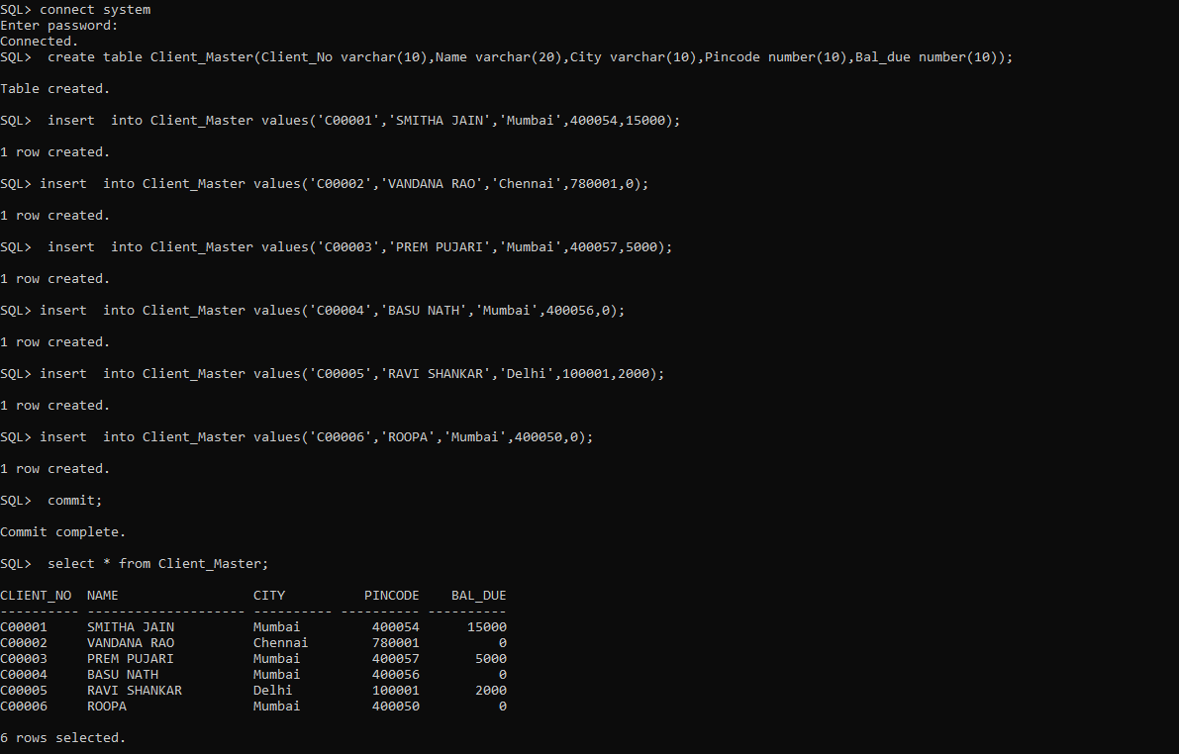

1. Create table for SaleOrder.

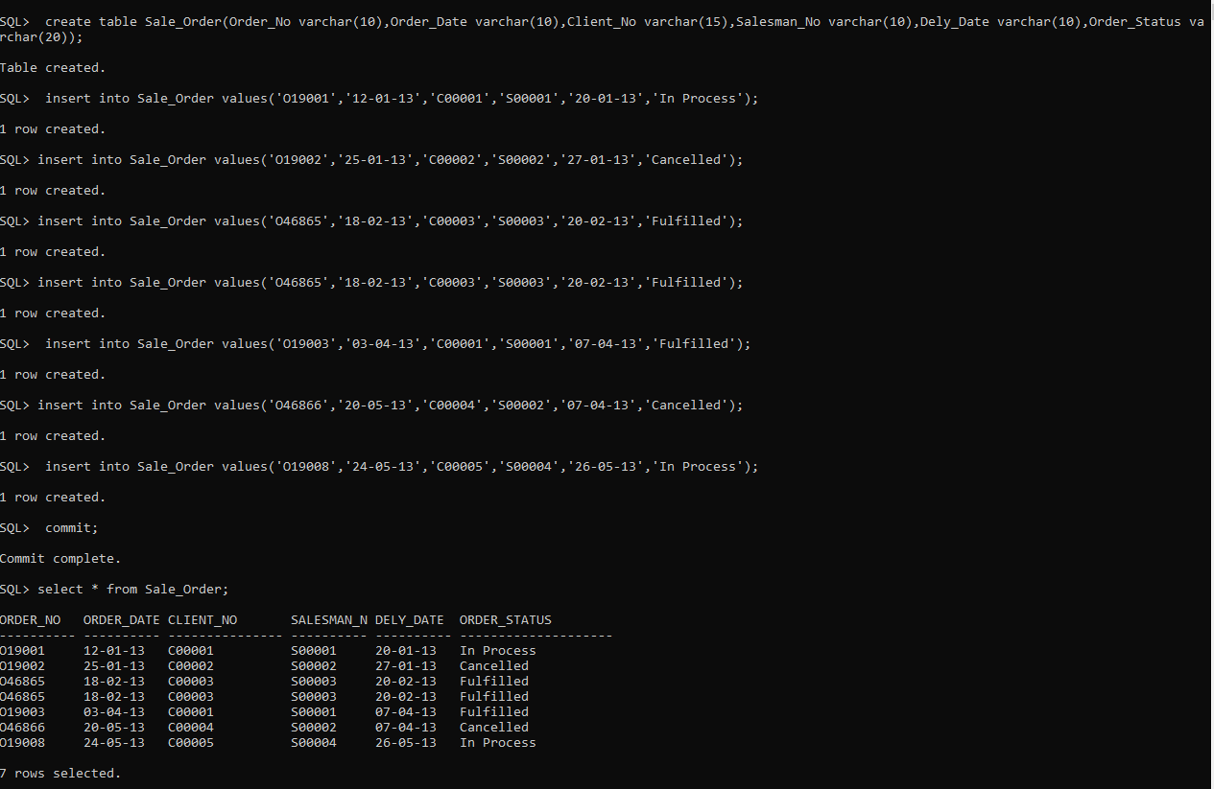

|  |  |
| --- | --- |
|  |  |

1. List all details from the client_master table for clients whose Bal_due = 0.

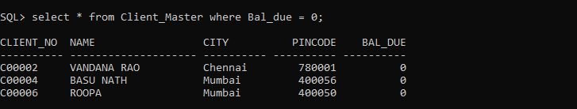

1. Update table client_master, Change city of Client_no C00004 to Jaipur.

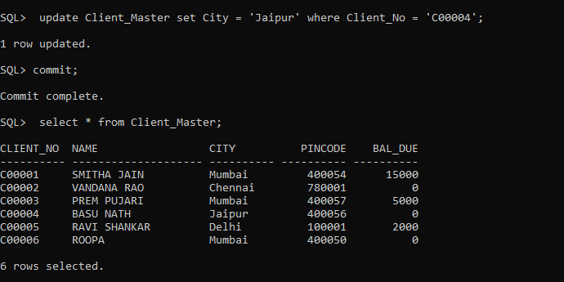

1. Retrieve records of clients residing in Mumbai.

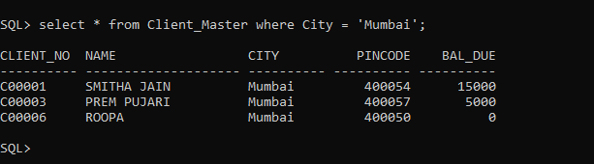

1. Find the name and address of customer who has placed Order_no 'O19003' and 'O19002' respectively.
2. Construct English like sentence from the table client_master ({Customer name} live in the city of {city}).
3. List the client_no, name, city and pincode of clients whose Order_status is "In process".